

**University College London**

Department of Information Studies

MSc Information Science

**Student Number (SRN):** 20040340

**Module Code and Title:** INST0012 Database Theory and Practise

**Lecturer Name:** Dr Andreas Vlachidis

**Assignment:** Assessed Exercise 2

**April 23rd 2021**

**1. MAPPINGS FROM CONCEPTUAL TO LOGICAL RELATIONAL REPRESENTATION:**

**1.1 MAPPINGS TO THE LOGICAL DATA MODEL**

EXAMINER(Employee-ID, Name, *Centre*)

*Centre*: foreign key refers to Location in relation Examination Centre: NULL not allowed

EXAM_OPPORTUNITY(ID, Date, *Tried-By*, *Assignee*, *Route*)

*Tried-By*: foreign key refers to SSN in relation Driving License Exam Applicant: NULL not allowed

*Assignee*: foreign key refers to Employee-ID in relation Examiner: NULL not allowed

*Rout*e: foreign key refers to Route-ID in relation Exam Driving Route: NULL not allowed

DRIVING_LICENSE_EXAM_APPLICANT(SSN, Name, *Taught-By*)

*Taught-By*: foreign key refers to SSN in relation Driving Instructor: NULL not allowed

EXAMINATION_CENTRE(Location)

EXAM_DRIVING_ROUTE(Route-ID, Possible-In-Winter, *Centre*)

*Centre*: foreign key refers to Location in relation Examination Centre: NULL not allowed

DRIVING_INSTRUCTOR(SSN, Name)

CAR(Registration, Brand, Year-Of-Purchase, *Company*)

*Company*: foreign key refers to VAT Number in relation Driving School Company: NULL not allowed

DRIVING_SCHOOL_COMPANY(VAT-Number, Name)

TRAINED_OFFICIAL_DRIVING_INSTRUCTOR_DI(*TODI-DI-SSN*, Years-Instructed, *Company*)

*TODI-DI-SSN*: foreign key refers to SSN in relation Driving Instructor: NULL not allowed

*Company*: foreign key refers to VAT Number in relation Driving School Company: NULL not allowed

FAMILY_MEMBER_DI (*FM-DI-SSN*)

*FM-DI-SSN*: foreign key refers to SSN in relation Driving Instructor: NULL not allowed

IS_TAUGHT_BY(*DLEA-SSN*, *DI-SSN*)

*DLEA-SSN*: foreign key refers to SSN in relation Driving License Exam Applicant: NULL not allowed

*DI-SSN*: foreign key refers to SSN in relation Driving Instructor: NULL not allowed

**1.2 INFORMATION ON LOSS OF SEMANTICS DUE TO MAPPING**

* The overlap specialisation of *Driving_Instructor* into *Trained_Official_Driving_ Instructor* and *Family_member* cannot be enforced. There is no attribute in the parent table which can enforce this. This has to be checked in the application layer (data entry layer).
* The minimum cardinality of 1 in the relationship type *Taught_By* between *Driving_License_*

*Exam_Applicant* and *Driving_Instructor* cannot be enforced. The reason for this is because there is no attribute or route to enforce this. Therefore, this will have to be checked in the application layer (data entry layer).

* The minimum cardinality of 2 in the relationship type *Driving_License_Exam_Applicant* and *Driving_Instructor* cannot be enforced. The reason for this is because there is no attribute or route to enforce this. Therefore, this will have to be checked in the application layer (data entry layer).

**1.3 NOTES**

* The green-coloured attributes are the attributes I have added which are not from the scenario

**2. DATABASE**

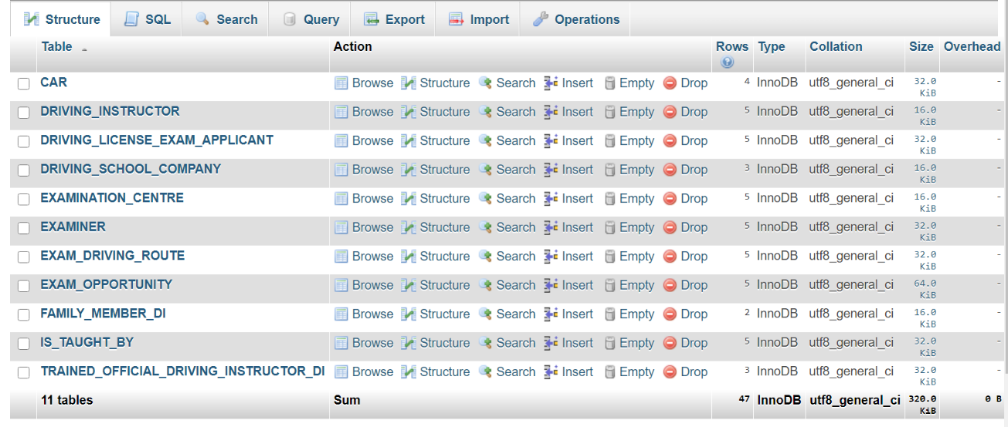**2.1 OVERALL DATABASE STRUCTURE**

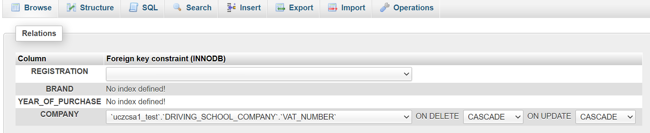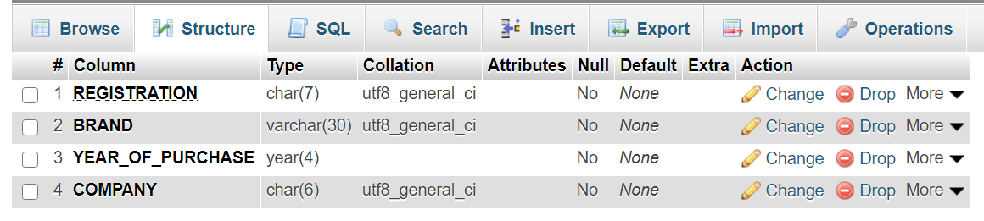**2.2 CAR**

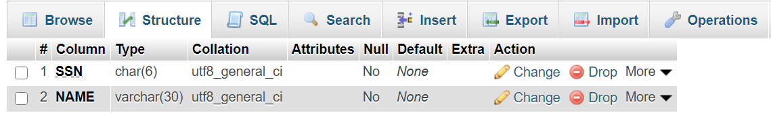**2.3 DRIVING INSTRUCTOR**

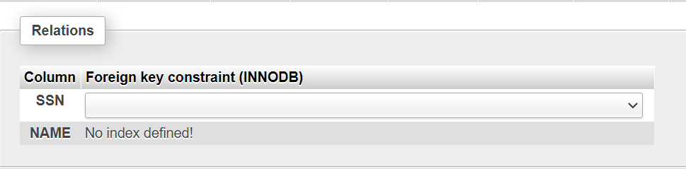

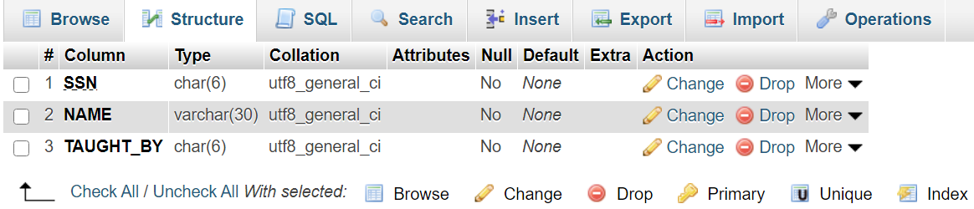**2.4 DRIVING_LICENSE_EXAM_APPLICANT**

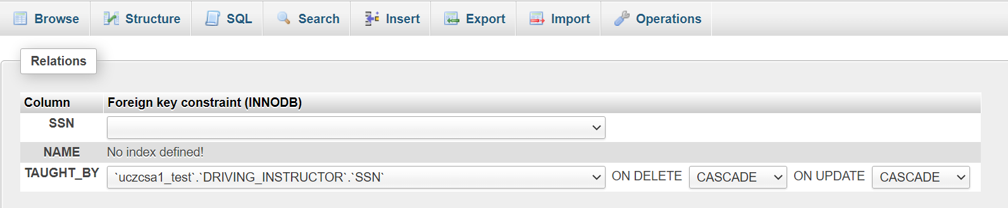

**2.5 DRIVING_SCHOOL_COMPANY**

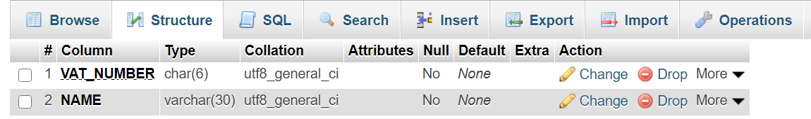

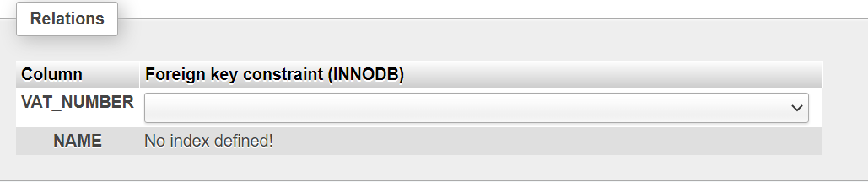

**2.6 EXAMINATION_CENTRE**

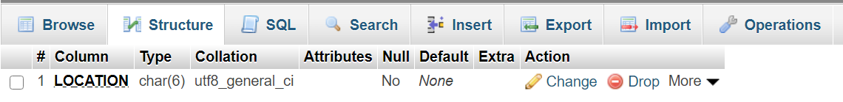

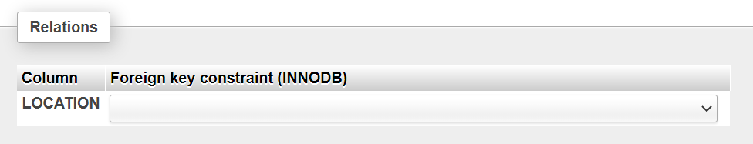

**2.7 EXAMINER**

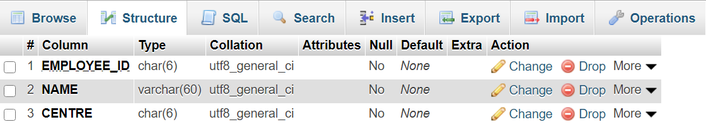

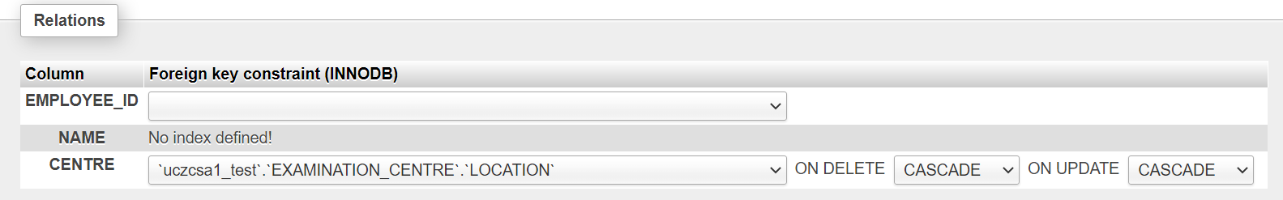

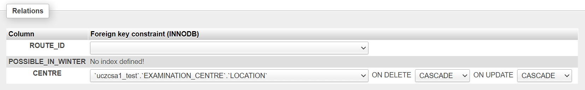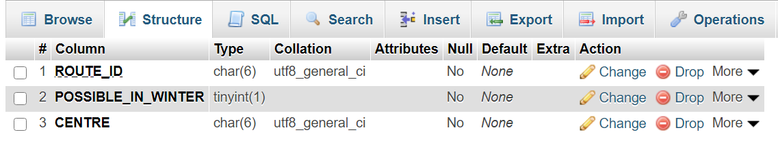**2.8 EXAM_DRIVING_ROUTE**

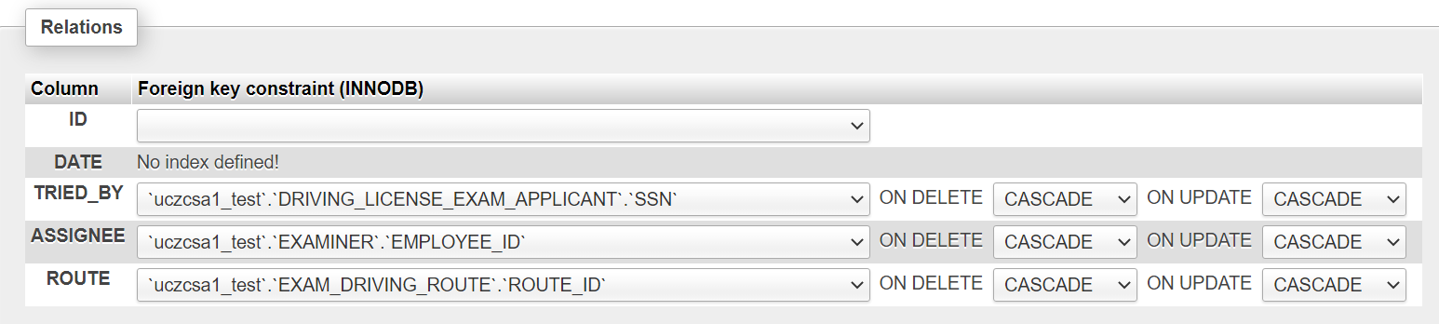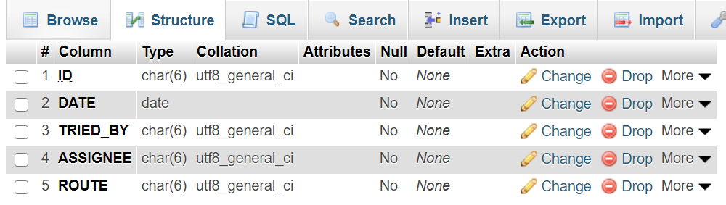**2.9 EXAM_OPPORTUNITY**

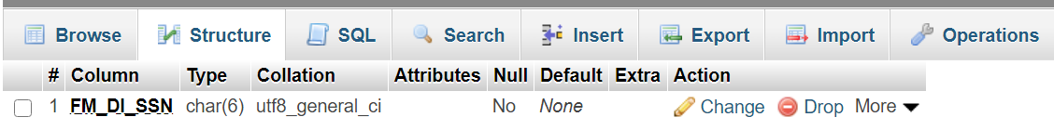**2.10 FAMILY_MEMBER_DI**

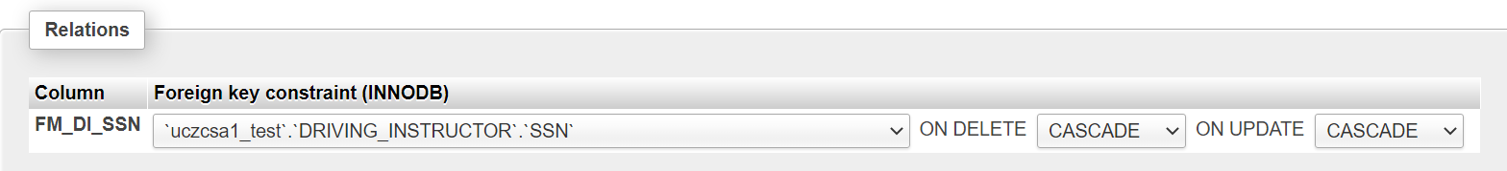

**2.11 IS_TAUGHT_BY**

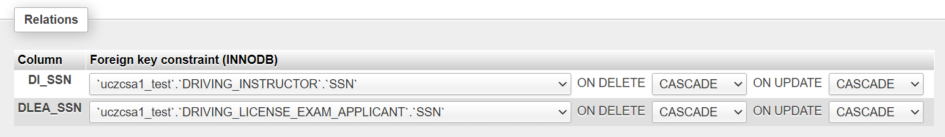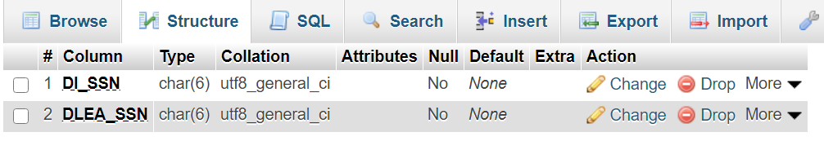

This table has been created as a new relation between Binary (N:M) relationship entities: *Driving License Exam Applicant and Driving Instructor*. The primary key of *IS_TAUGHT_BY*  is a combination of foreign keys referring to the primary keys of the relations corresponding to the participating entity types.

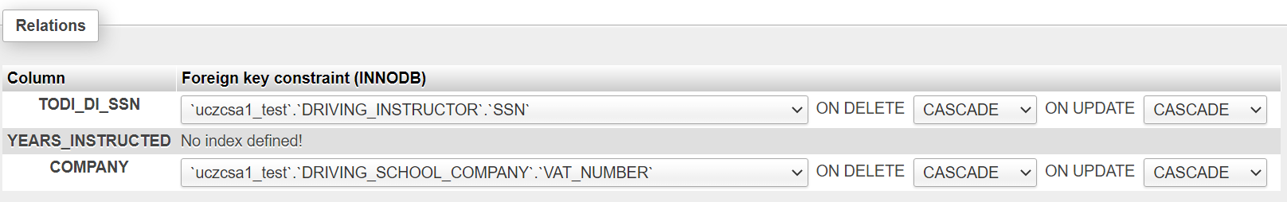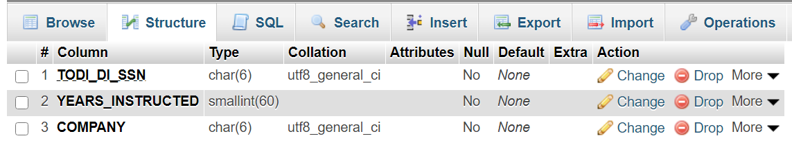**2.12 TRAINED_OFFICIAL_DRIVING_INSTRUCTOR_DI**

**2.13 NOTES**

* MySQL automatically converts boolean data types (the attribute *Possible_In_Winter* from *Exam_Driving_Route*) into *tinyint* data types. The 0 represents *FALSE* and 1 represents *TRUE*

**3. SQL QUERIES**

**QUERY 1**

*An SQL Update statement using WHERE*

This query updates the brand of the car whose registration is ‘ZX36KLY’, from ‘LAMBORGHINI’ to ‘NISSAN’

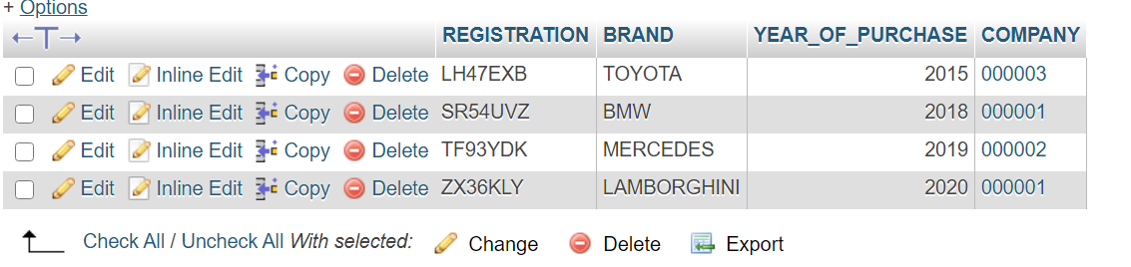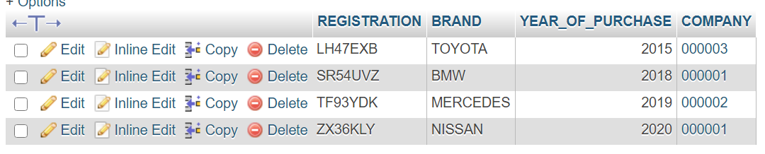

**QUERY 2**

*An outer join SQL query*

Performs a right outer join between the ‘CAR’ and ‘DRIVING_SCHOOL_COMPANY’ on the COMPANY (VAT_NUMBER) column.

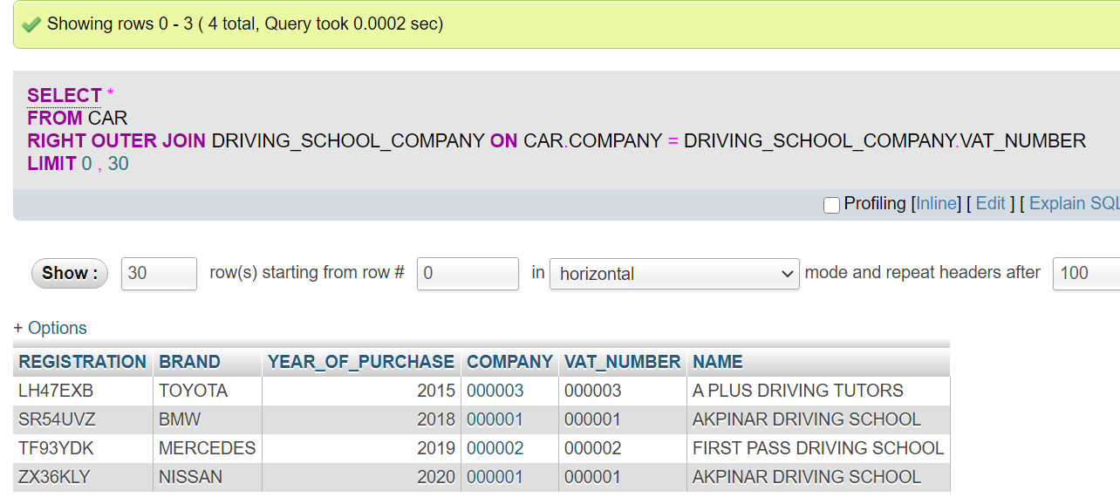

**QUERY 3**

*A correlated SQL query with NOT EXISTS*

Returns all the ‘EXAMINER’ IDs and Names who have not been assigned to an ‘EXAM OPPORTUNITY’ (examiners who have not been assigned to any exams). ‘AS’ has been used to change the column names accordingly. ‘ORDER BY’ and ‘ASC’ have been used to order the results by ascending ‘EMPLOYEE_ID’. (Note: *Inline* option on the query has been selected to ensure the whole query can be viewed).

